








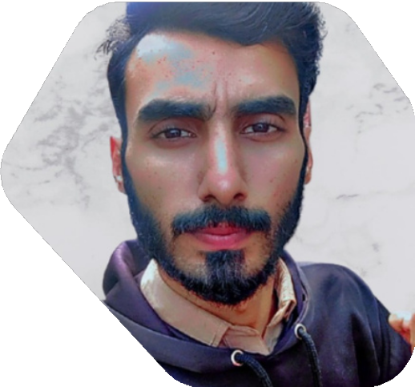
Muhammad Bilal
Computer Operator

contact
0309-9007603
bilalmalik03245733904@gmail.com Chakri Road St # 05 Rawalpindi

Profile
I am energetic, honest and hardworking. I want to become an integral part of any organization with honesty and hard work. I would like to accept challenges and developed further.

Skills

IT Technician Window Installation Software/ Hardware Troubleshooting

Language
English Urdu Punjabi

Work Experience
Combined Military Hospital Rawalpindi IT Technician (Nov 2021 - Present)
Bilal Hospital Rawalpindi Cashier (Jan 2020 - June 2021)
Mir Electronic Showroom Rawalpindi Sale Manager/ Computer Operator
(Jan 2018 - Jan 2020)
AC Technician Shop Rawalpindi (Feb 2017 - Jan 2018)

Education
Matric Science (F.G Public Secondary School, Mehfooz Road, Rawalpindi) 2018
F.A (IN progress) Allama Iqbal Open University Islamabad 2023

